**FORECASTIFY EDU – By SAF**

📝 **Exercise: Forecasting Sales Based on Past Data**

📘 **Instructions:**

Study the 5-year sales trend of the product shown in Table 1. Using the data provided, calculate the forecasted sales for the next 3 years. Apply the given percentage adjustments to estimate future sales. Then, illustrate the full data using graph. The forecasted sales are projected to increase by 10% in 2025, followed by a further 20% increase in 2026. However, in 2027, sales are expected to decline by 5% compared to the previous year.

📊 **Table 1: Product Sales Data (Past 5 Years)**

|  |  |
| --- | --- |
| **Year** | **Sales (Units)** |
| 2020 | 4500 |
| 2021 | 4700 |
| 2022 | 5000 |
| 2023 | 5400 |
| 2024 | 5800 |

✏️ **Questions:**

1. **Based on the trend, calculate the forecasted sales for:**
   * 2025 (+10%)
   * 2026 (+20%)
   * 2027 (-5%)

📋 **Answer Table:**

|  |  |
| --- | --- |
| **Year** | **Sales (Units)** |
| 2020 | 4500 |
| 2021 | 4700 |
| 2022 | 5000 |
| 2023 | 5400 |
| 2024 | 5800 |
| **2025** | **6380 (+10%)** |
| **2026** | **7656 (+20%)** |
| **2027** | **7273 (-5%)** |

** Sales Forecast Graph:**

Draw a line graph showing **actual sales (2020–2024)** and **forecasted sales (2025–2027)** on the same chart.

* + - **X-axis**: Year (2020–2027)
    - **Y-axis**: Sales (Units)
    - Use different colors to show:
      * Actual sales
      * Forecasted sales

*Graph Highlights:*

* Blue Line = **Actual Sales** (2020–2024)
* Orange Dashed Line = **Forecasted Sales** (2025–2027)

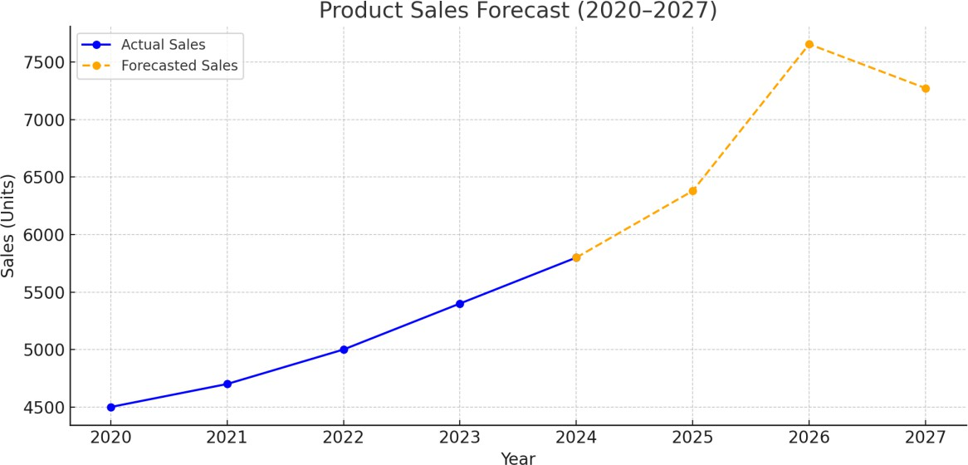

* + - *Warna Merah dan biru (dalam jadual) berubah mengikut soalan latihan, pelajar akan masukkan ke dalam sistem. Bilangan tahun boleh lebih banyak, maksimum 10 tahun.*

*Flow Sistem:*

1. *Masukkan data dalam jadual, sistem akan kirakan.*
2. *Buat ramalan bagi tahun akan datang, sistem akan kirakan.*

*(ramalan akan menggunakan % kenaikan atau penurunan jualan dalam soalan aktiviti)*

1. *Pamerkan dalam bentuk graf (ada pilihan graf untuk dijana).*